Database Management Information System Project

CPIS-340, Section: AE

Supermarket Domain

Student’s Name: Abdullah Mansour Kimrigh

Student’s ID: 1743285

Table of Contents

1. Domain Statement: 2

2. Entity-Relation Diagram: 3

3. Database Schema: 4

4. Tables Description: 5

5. SQL Statement: 7

# Domain Statement:

The supermarket is a store that collects under one roof a wide range of products as foods, beverages, non-foods products, household products, and else.

Many supermarket branches open in several cities in different countries. Each of these branches has inventory divided into Classes by product type, and the store employs a group of employees to be appointed as a branch manager, inventory management officials, employees for serves the customers. Each branch is served by suppliers to supply the branch with different sets of products that are kept in stock.. the employees turn to display these products on the shelves. Then customers come to choose the products they want and open the order and pay for it, this order contains all products they choose, description of each product, their price and quantity, the employee name who serve, and the order date.

# Entity-Relation Diagram:

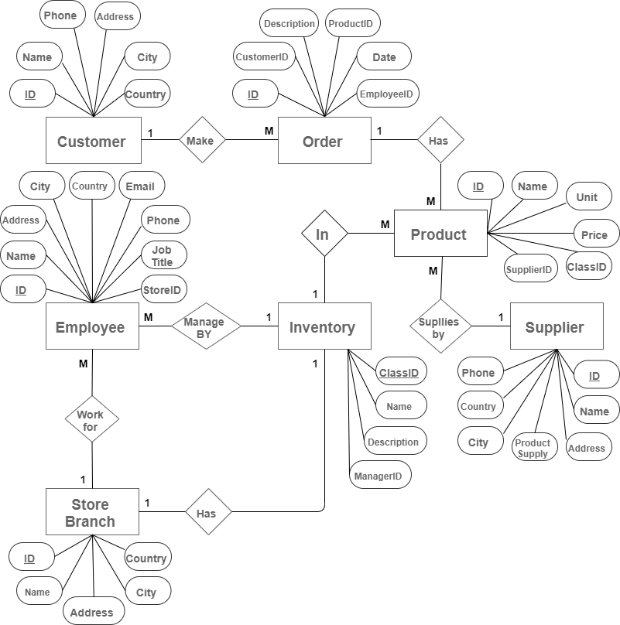

# Database Schema:

# Tables Description:

|  |  |  |
| --- | --- | --- |
| Customers Table | | |
| Field | Datatype | Constraint |
| ID | AutoNumber | Primary Key |
| Name | Varchar(255) | Not Null |
| Address | Varchar(155) |  |
| City | Varchar(155) |  |
| Country | Varchar(155) |  |
| Phone | Number |  |

|  |  |  |
| --- | --- | --- |
| Orders Table | | |
| Field | Datatype | Constraint |
| ID | AutoNumber | Primary Key |
| CustomerID | Number | Constraint Foreign Key, reference Customers.ID |
| ProductID | Number | Constraint Foreign Key, reference Products.ID |
| EmployeeID | Number | Constraint Foreign Key, reference Employees.ID |
| Description | Varchar(255) |  |
| Date | Date |  |

|  |  |  |
| --- | --- | --- |
| Products Table | | |
| Field | Datatype | Constraint |
| ID | AutoNumber | Primary Key |
| Name | Varchar(255) | Not Null |
| Unite | Number |  |
| Price | Currency |  |
| ClassID | Number | Constraint Foreign Key, reference Inventory. ClassID |
| SupplierID | Number | Constraint Foreign Key, reference Suppliers.ID |

|  |  |  |
| --- | --- | --- |
| Suppliers Table | | |
| Field | Datatype | Constraint |
| ID | AutoNumber | Primary Key |
| Name | Varchar(255) | Not Null |
| Address | Varchar(155) |  |
| City | Varchar(155) |  |
| Country | Varchar(155) |  |
| Phone | Number |  |
| ProductSupply | Varchar(255) |  |

|  |  |  |
| --- | --- | --- |
| Inventory Table | | |
| Field | Datatype | Constraint |
| ClassID | AutoNumber | Primary Key |
| Name | Varchar(255) | Not Null |
| Description | Varchar(255) |  |
| ManagerID | Number | Constraint Foreign Key, reference Employees. ID |

|  |  |  |
| --- | --- | --- |
| StoreBranches Table | | |
| Field | Datatype | Constraint |
| ID | AutoNumber | Primary Key |
| Name | Varchar(255) | Not Null |
| Address | Varchar(155) |  |
| City | Varchar(155) |  |
| Country | Varchar(155) |  |

|  |  |  |
| --- | --- | --- |
| Employees Table | | |
| Field | Datatype | Constraint |
| ID | AutoNumber | Primary Key |
| Name | Varchar(255) | Not Null |
| Address | Varchar(155) |  |
| City | Varchar(155) |  |
| Country | Varchar(155) |  |
| Phone | Number |  |
| Email | Varchar(155) |  |
| Job Title | Varchar(155) |  |
| StoreID | Number | Constraint Foreign Key, reference StoreBranches. ID |

# SQL Statement:

Create Table Customers (

ID Int Primary Key,

Name Varchar(255) Not Null,

Address Varchar(155),

City varchar(155),

Country Varchar(155),

Phone Number);

Create Table Employees (

ID Int Primary Key,

Name Varchar(255) Not Null,

Address Varchar(255),

City Varchar(155),

Country Varchar(155),

Phone Number,

Email Varchar(155),

JobTitle Varchar(155),

StoreID Number Constraint Foreign Key(StoreID)

References StoreBranches**.**ID

On Update Cascade);

Create Table Orders (

ID Int Primary Key,

CustomerID Number Constraint Foreign Key(CustomerID)

References Customers**.**ID

On Update Cascade,

EmployeeID Number Constraint Foreign Key(EmployeeID)

References Employees**.**ID

On Update Cascade,

ProductID Number Constraint Foreign Key(ProductID)

References Products**.**ID

On Update Cascade,

Description Varchar(255),

Date Date);

Create Table Products (

ID Int Primary Key,

Name Varchar(255) Not Null,

Unite Number,

Price Number,

ClassID Number Constraint Foreign Key(ClassID)

References Inventory**.**ClassID

On Update Cascade,

SupplierID Number Constraint Foreign Key(SupplierID)

References Suppliers**.**ID

On Update Cascade);

Create Table Suppliers (

ID Int Primary Key,

Name Varchar(255) Not Null,

Address Varchar(255),

City Varchar(255),

Country Varchar(255),

Phone Number

Product Supply Varchar(255));

Create Table Inventory (

ClassID Int Primary Key,

Name Varchar(255) Not Null,

Description Varchar(255),

ManagerID Number Constraint Foreign Key(EmployeeID)

References Employees**.**ID

On Update Cascade);

Create Table StoreBranches (

ID Int Primary Key,

Name Varchar(255) Not Null,

Address Varchar(255),

City Varchar(255),

Country Varchar(255);